**Name:** V Venkata Sri Prasad

**Batch:** Data Engineering

**Date:** 27/02/2024 – (Day 29)

Topics:

1. Creating Azure Synapse Analytics and creating a pipeline

Go to home page and click on synapse analytics and click on create.

Provide proper details like resource group, name , region, account name.

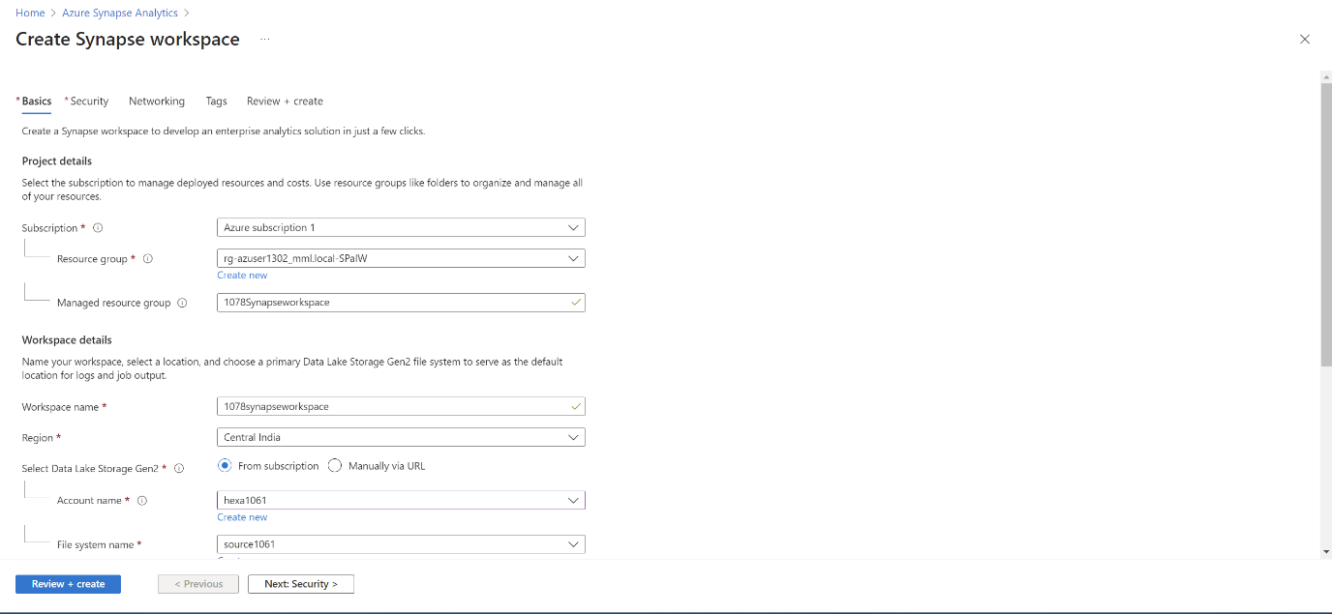

In the security session provide proper password.

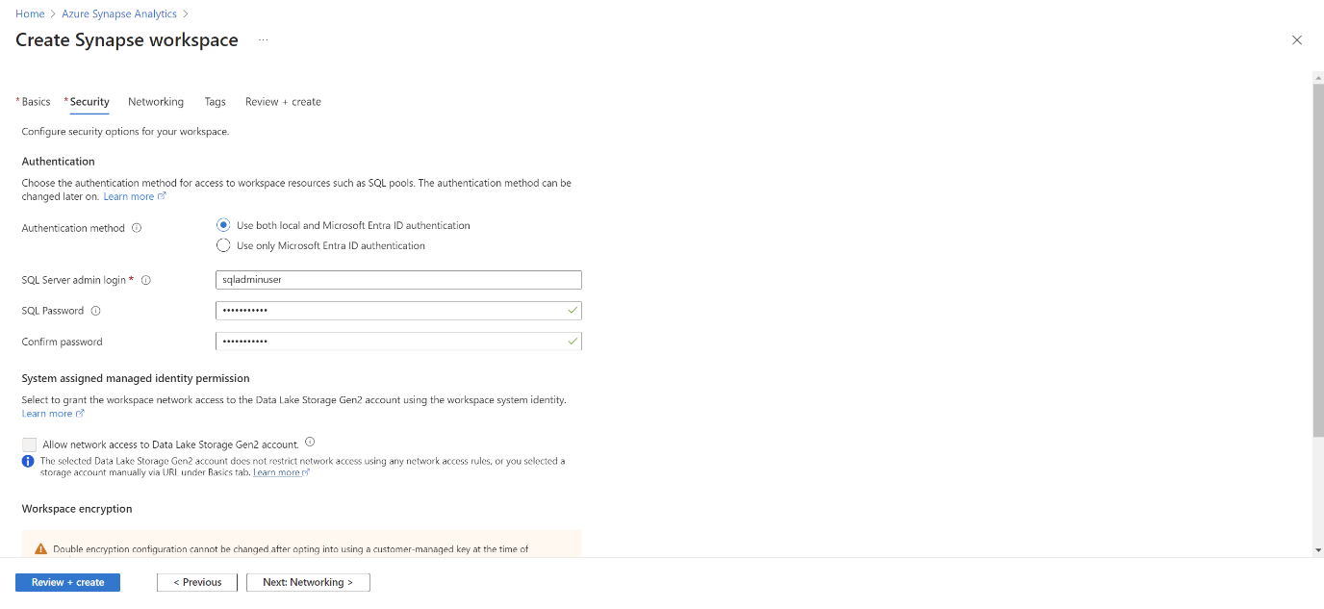

Validation is successful and click on create.

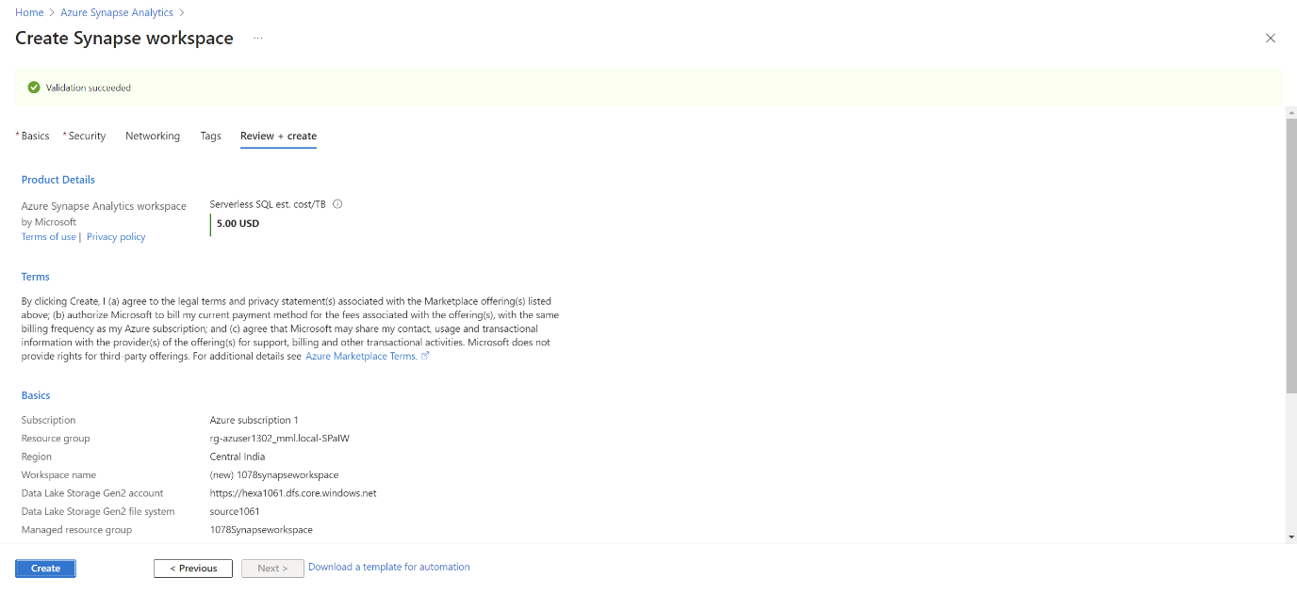

Your deployment is successful.

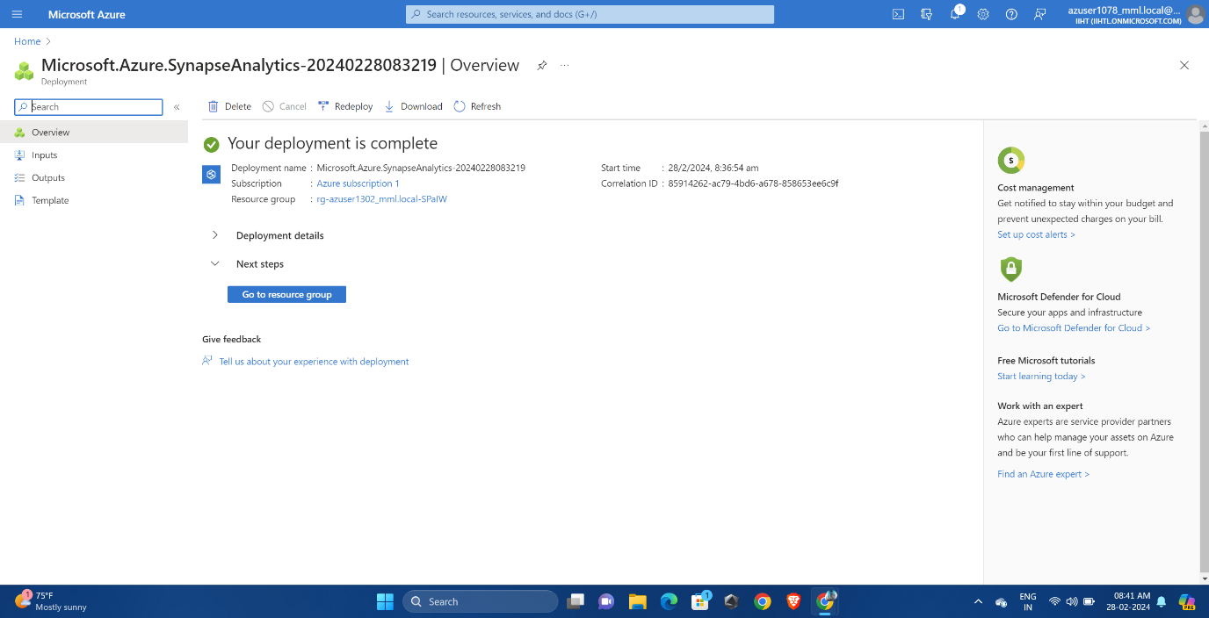

Click on open resource and select your workspace.

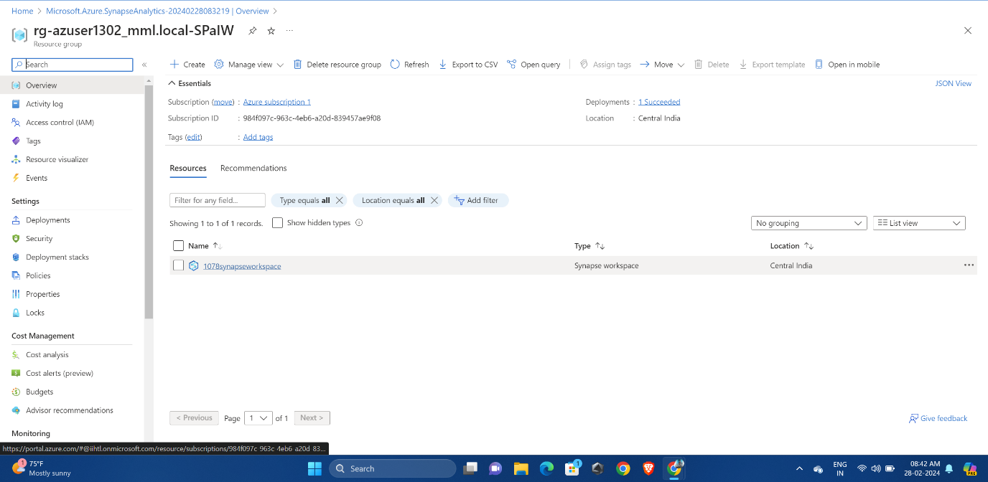

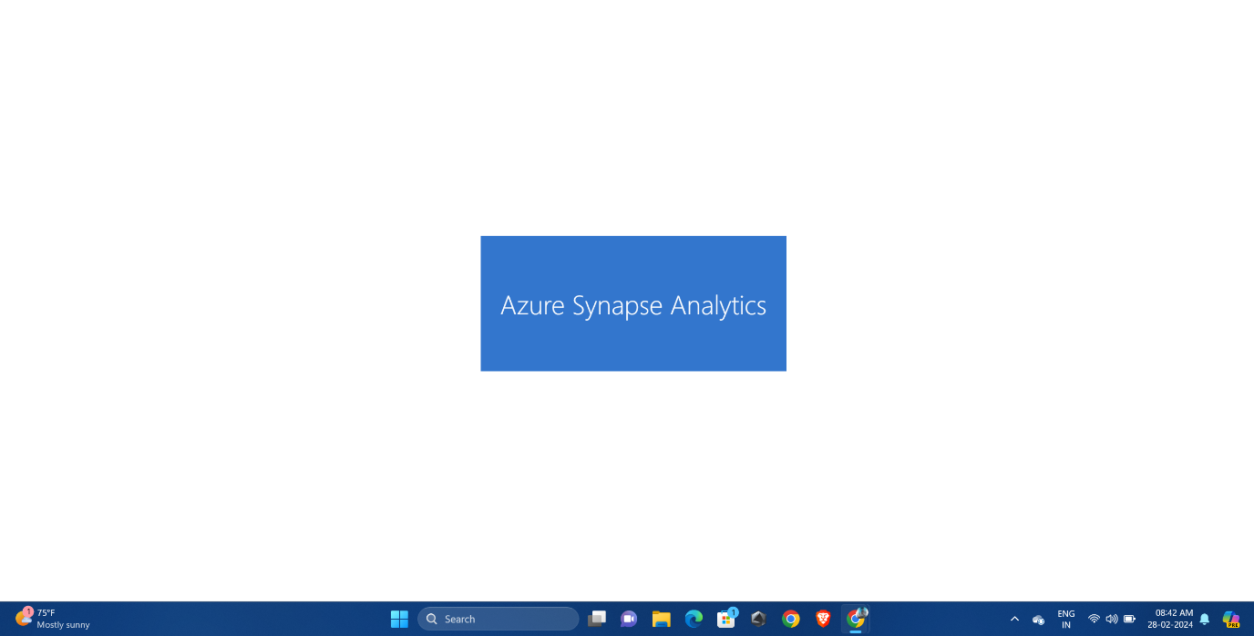

We can see here there are several options we can perform in the workspace.

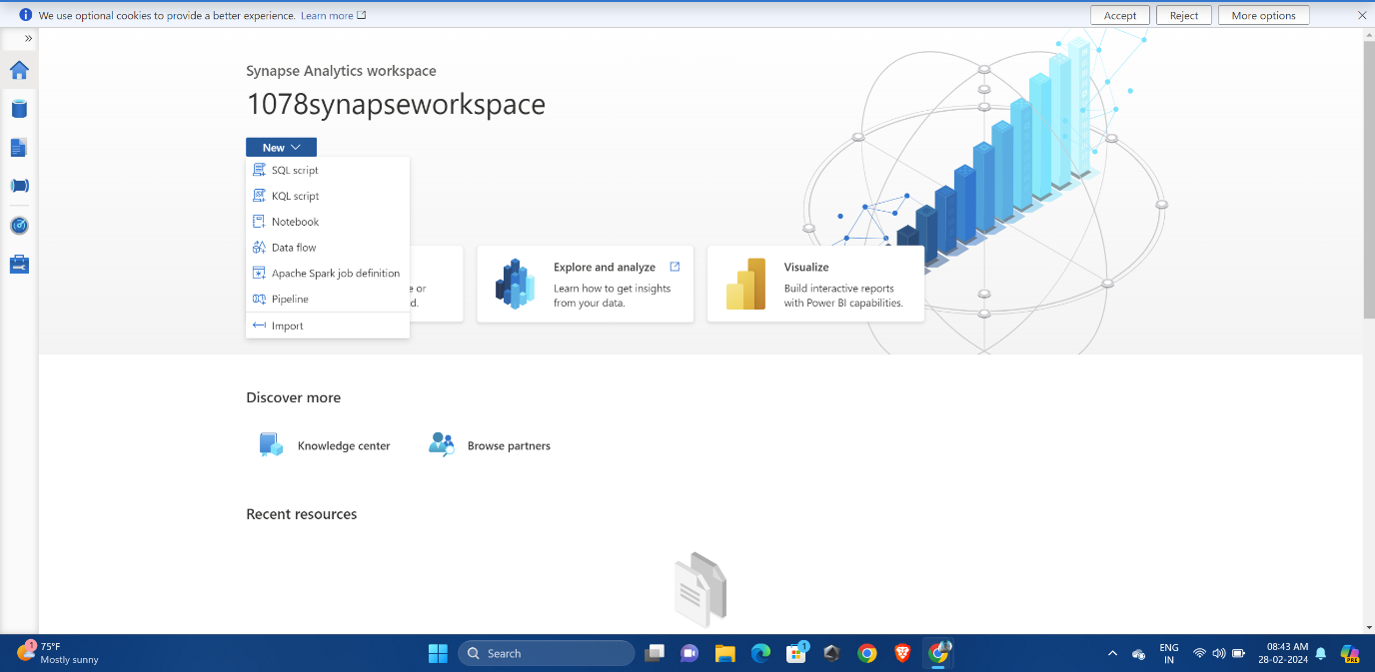

In pipeline session, we can see there are different platfoms we can integrated them by dragging them in the workspace.

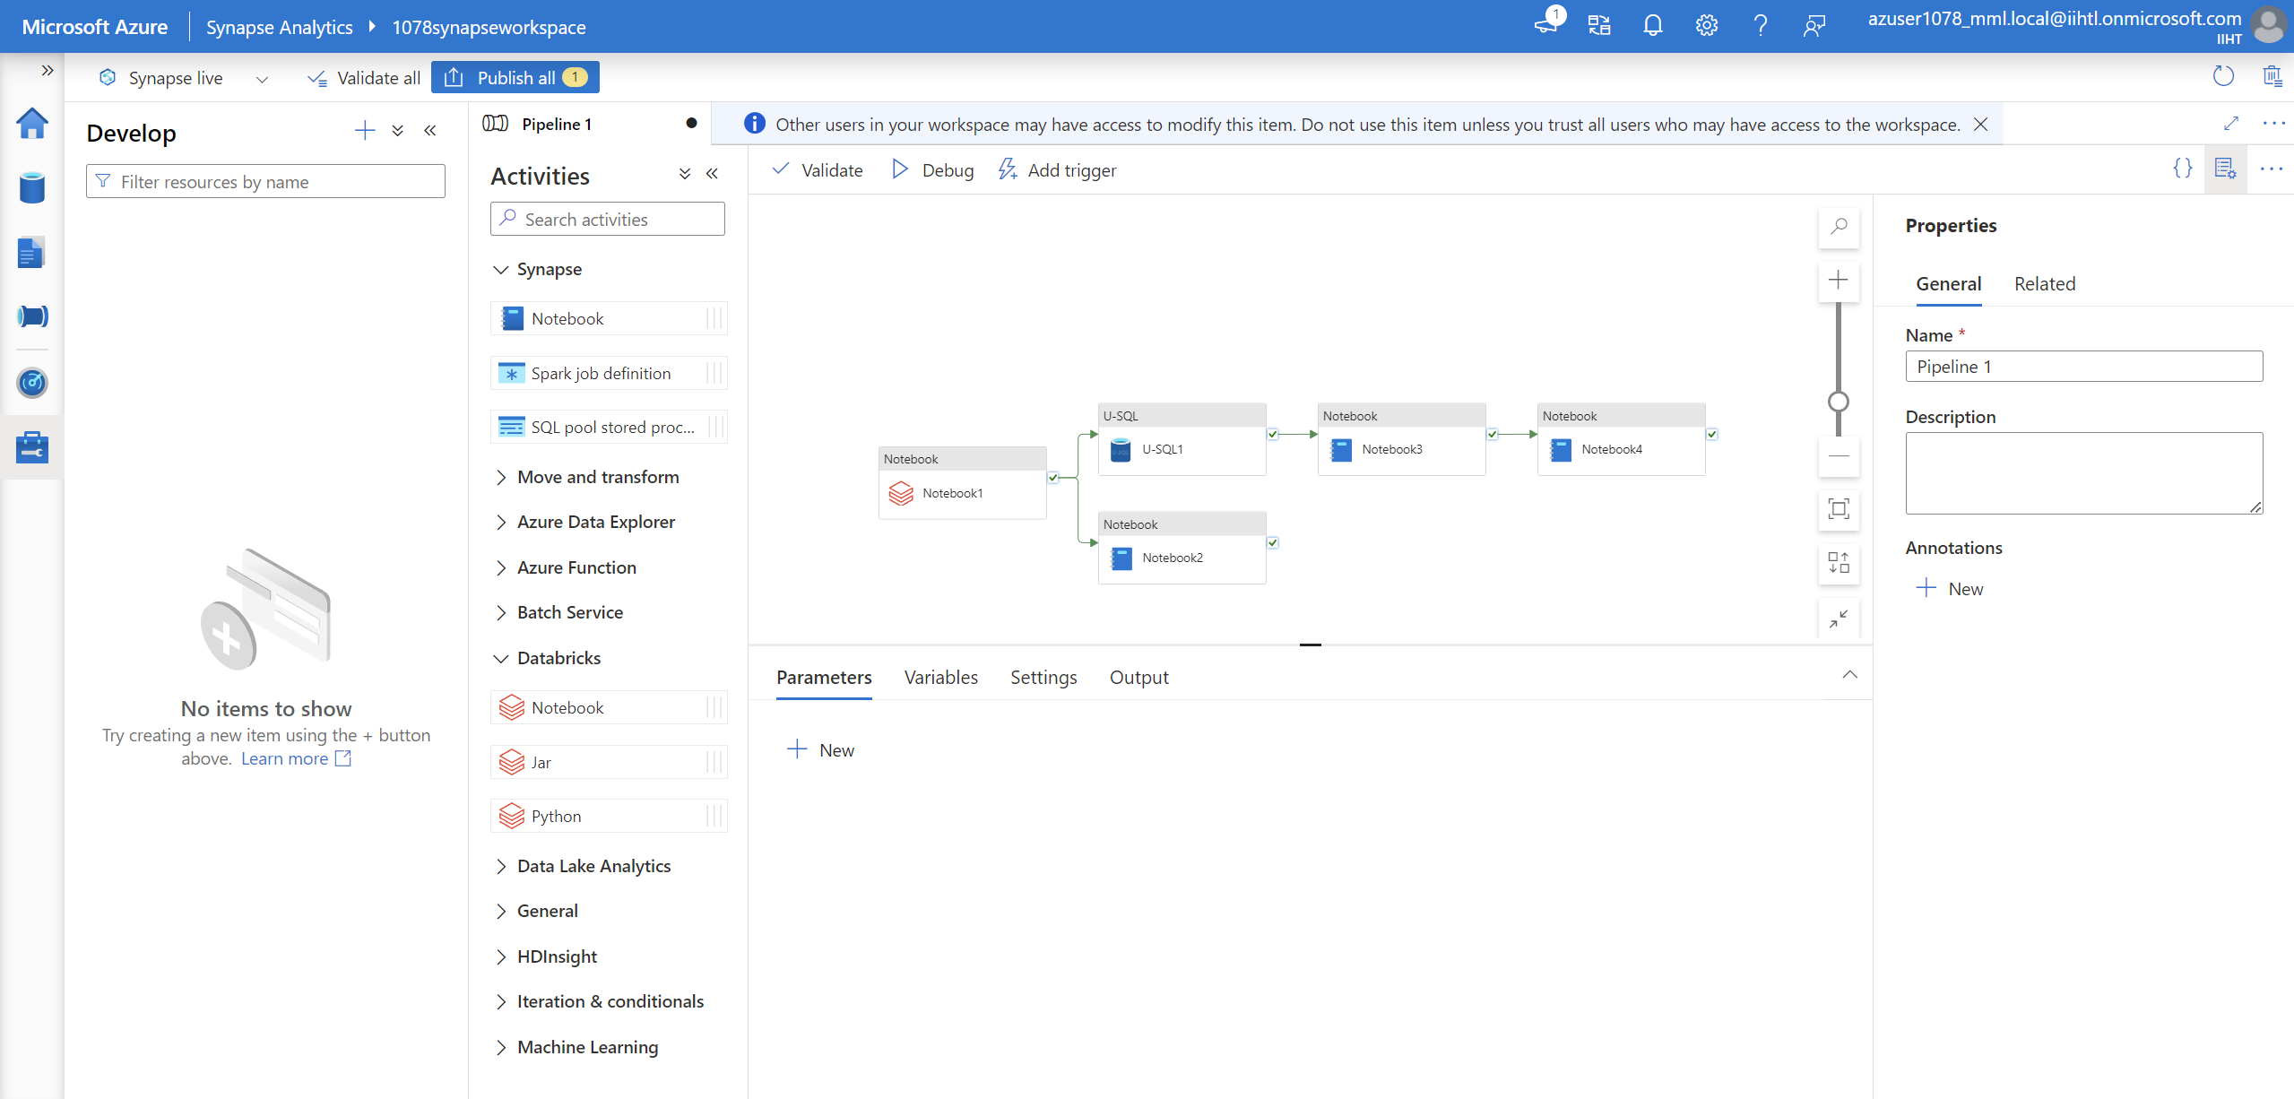

Provide proper path and access keys.

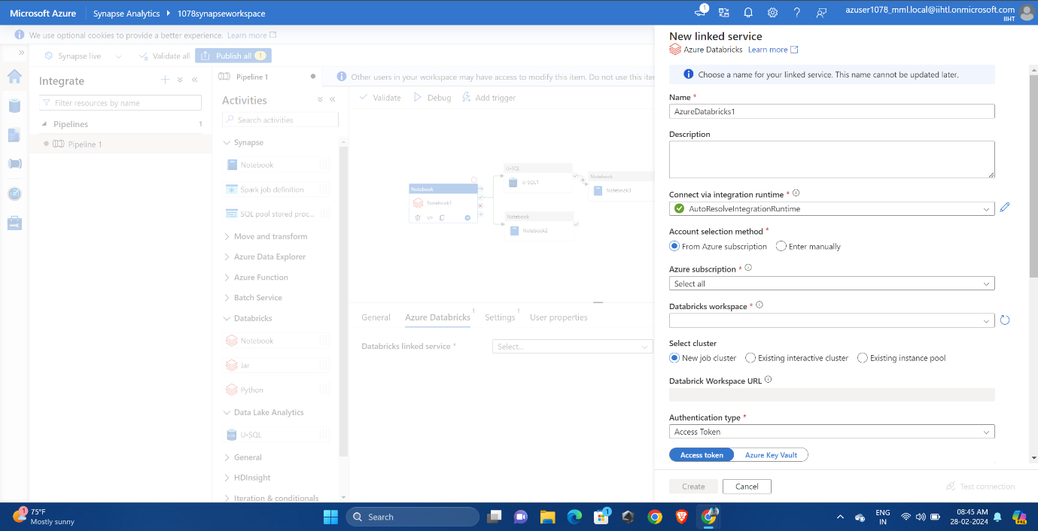

We can validate individual platform by selecting them.

